01/07/2021

Leo Comte

[nom de la société]

Expérience bénévole

Banque alimentaire de Lisbonne

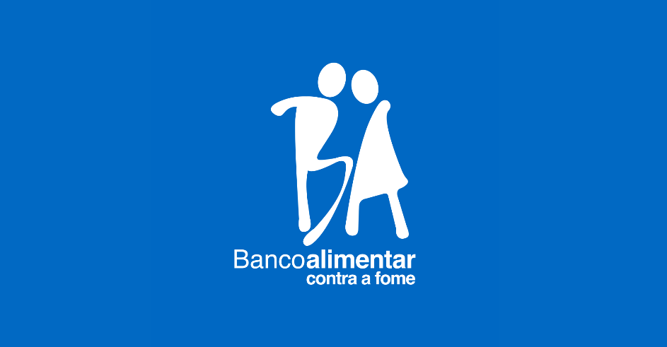

Table des matières

Présentation de l’association 2

Travail effectué 3

Notion d’engagement citoyen 4

Conclusion 5

# Présentation de l’association

For my internship, I went in Lisbon to work during one month in the Banco Alimentar contra a Fome (food bank against the hunger). So I’m going to present you this NGO.

You have to know that the Banco Alimentar is a group of food banks. There are twenty one in Portugal. In this internship report, we are going to focus on the Lisbon’s food bank.

The main goal of the Banco Alimentar is to retrieve the food which is going to be wasted and give this food to the people in need. All this represents several steps.

The first one is to retrieve the food. In 2019, the Bank food gathered more than 7000 tonnes of food. It comes from the supermarket (44,2%), the farmers (9,3%), the MARL which is like Rungis in Paris (27,6%) and from the donation campaigns (15,8%). We can see that the donations represent a significant part. The other 84% of food are food which can’t be sold anymore. It can be because of the deadline, a surplus of production, vegetable which are too ugly or a wrong labelling. In this way, the food bank reduce the food wast.

The second step is to stock and to spread the food. The Banco alimentar have many warehouse where they stock the fresh and the non-perishable food.

All this food go to the NGO. Indeed, Banco Alimentar don’t give food directly to the people in need. They give the food to different NGO which shared the food to the people. These NGO can give directly the food or prepare some meal. To give some key figures, the food bank is link with 375 institution in Lisbon and its suburbs and every day, 75 of theme come take food in the Banco Alimentar.

This operating mode allows to retrieve more food and then share it with more people. In 2019, the Banco Alimentar supported 66 thousand of people giving more than 12 millions of meals. I would remind you that there around three millions of people living in Lisbon and its area. We can observe that there are still a lot of of people helped by the food bank in Lisbon.

All of this require a lot of labour. But the food bank works quite only thank to volunteers. Only few people are payed to work there every day.

So the Banco Alimentar live thank to volunteers and donations. The food bank do great collect twice a year to gather some money and food. Also it do campaigns to sensitize young people in the schools. I could work with people from different social environment ; tenageers, students, unemployed people or even retirees.

12 millions of meals in 2019

60 tonnes of food in movment every day

375 institutions in link





66 212 people helped

75 institutions served every days

# Travail effectué

In the second part, I’m going to talk about my experience and what I did in the food bank. During one month, I made some different task and each one was very important for the food bank’s proper functioning.

The first tas kwas to prepare the fresh food orders of each NGO. The fresh food is comprised of some fruts and vegetable, some dairy products, cakes and meats. To prepare the orders, we have lists on which there are the differents foods and the quantities. So we have to take the food we need and put it on pallet. When it’s done, we check all the products we have brought and we report the missing products. Then we sign and we take an other list.

The commands’ size were constantly changing. The smalest were around 100kg and the biggest were around one tonne and an half. According to the experience in the Banco Alimentar, we could do command more or less important. On my side, I started with the smallest command. Then I have made some progress and at the end of my internship I did only the largest command. I was quite proud of myself with this improvment.

The second task looks like the first one. Indeed it’s order picking for the non-perishable food. In the non-perishable food we can find some rice, paste, oil, cereale or even hygienic products like toothbrush.

Like the first tasks, we had list on wich there were all the food we should put in a box. A box is a pallet on which we put a steel grid. For this task we didn’t have the quantities but only the weight. For example, in stead of 50 bottle of oil we had 60kg. So we to weigh everythnig. To this end we had some pallet scale. When we were a lot of volunteer and the pallet scale were not available, we could use also a big scale but it’s was a bit longer.

The non-perishable food can stay in the warehouse a lot time. Therefore there are less command but thez are bigger. They were between 500kg and two tonnes. And as we didn’t know the number of products but only the weigh, this command took much more time. As an example, we could make around 30 fresh food’s commands but only three commands of non-perishable food during the afternoon.

The third task is simpler than the others. Indeed, it’s about sort and store the stock. Indeed the food bank receive a lot of food and sometimes it comes untidy. In this case we have to put it in boxes to facilitate the storage. Of course we do that only with the non-perishable because the fresh food don’t stay more than one or two days in the warehouses.

This task is very usefull when the Banco Alimentar does food collects. Indeed they are composed of a lot of différents bulk products.

Know i am going to present you a ordinary day in the food bank. The days there were really organised.

The day begin at 9 and an half and it’s always the same. A leader presents us the fresh products of the day. Then we start the orders. The morning is split in two. The first part we do the orders which are being taken in the morning. When did all the orders, we have a break. The other NGO come to take their command. When it’s done, we can do the « afternoon part ». That’s mean the command we do are being taken in the afternoon. So we don’t put the frozen food on the pallet (the frozen food are considered as the fresh food). When it’s done, the morning part is finished. This part was the most tiring because we had to be fast and to carry heavy products. It was done quite only by volunteers. The number of volunteers was changing every days.

Then we had a break during two hours. It allowed to meet the other volunteers.

During the afternoon we can make different activités. Most of the time I do the non-perishable food. If there were no food, we could finish the « afternoon’s order ». That’s mean putting the frozen food on it. Indeed we don’t put the frozen food during the morning to not let it to much time outside of the freezers. When it’s done, i can store the food. There is always something to do in the Banco Alimentar.

# Notion d’engagement citoyen

We can define the civic commitment as a participation in the society life and a contribution for the common good. The civic commitment internship is at first an social experience which tend to understand and stand against the society issues as the inequalities, the environnement issues or the poverty.

My internship allows me to realise that even in our rich countries, there are still a lot of people who need food. In addition to this, there is also a lot of food which is wasted. Even if we all know that, when you see that during one month, it’s immediately more concrete.

Nevertheless, I was pleasantly surprised when i saw all the volunteer, young or old, who were really involved to help people in need.

The food bank has two main goal ; reducing the food waste by collecting food which was intended to be thrown away. Then giving it to people who are hungry. The first one is ecologic and the second one is social.

When I worked in the food bank, I did a lot things which helped to redistribute the food. I gave my time to be usefull for other people and so for the society. Therefore we can qualify my internship as an civic commitment.

# Conclusion

To conclude, the Banco Alimenta is an important NGO which help thousand of people thank to a perfect organisation. During my internship, I was quite impressed by the fact that there was quite no loss. Nevertheless, it doesn’t work without all its volunteers. Indeed, thank to this internship, I realise that everyone can be usefull for the society, just giving some time and good faith. Each participation, even if it seems not a lot, it’s important.

Maybe I can regret to not having been able to meet people I helped. However, the meetings I did in the food bank were also really rewarding. I worked with people who come from all walks of life and all ages, from 14 to 80 years old. I realised that the age doesn’t matter. If you want to help people you can be young or old, we don’t mind ! The will is the only thing that matters.

Finaly, I want to say that it was a great experience and I’m sure i would do volunteering again in my life !